Euro Health Consumer Index 2014:
A radical healthcare overhaul needed in Malta, to cure constant underperformance in access and outcomes

(Brussels, January 27, 2015)
Malta ranks 27th in the 2014 Euro Health Consumer Index, scoring 582 points out of the maximum 1000, a loss of one position since the 2013 study.
The 8th edition of the EHCI was presented today in Brussels in the presence of the EU Health Commissioner Vytenis Andriukaitis. The Netherlands stay on top, gaining 898 out of maximum 1 000 points, followed by Switzerland, Norway, Finland and Denmark. The study includes 36 countries plus Scotland.
- In spite of slightly reduced spending on healthcare in many countries, overall healthcare performance keeps improving, explains Dr. Arne Bjornberg, HCP chairman and head of research. The initial measurement 2006 awarded just one country with more than 800 out of maximum 1000 points. 2014 there are no less than nine such high-performing healthcare systems!
Malta moves with the crowd, meaning a higher number of Index points 2014 as its healthcare improves overall. For Malta that is not enough to keep the rank, as competing countries improve even more. Malta has strengthened patient information, improved the range and reach of services and become more active in prevention. It looks as if Malta finally has tried to address the severe diabetes problem on the island, with efforts to reduce sugar intake and improve blood pressure monitoring. But there remains a lot to do!
Recommendations for Maltese improvement
- In spite of some improvement, most of the weaknesses we have identified for several years still remain, finds Dr. Bjornberg. Waiting times are too long and medical outcomes not even mediocre. Infant deaths, a very revealing indicator, are still alarmingly high at a level otherwise known only in poor South-Eastern Europe. The abortion ban not only discriminates against women but is a threat to good health.
- When we started to observe the Maltese healthcare performance we often heard the assurance that the new Mater Dei hospital in Valetta would mean a big change and do away with hospital infections and poor treatment outcomes. That was 2007. We now have the sad record: very little has really improved. Malta is in need of a radical healthcare overhaul!
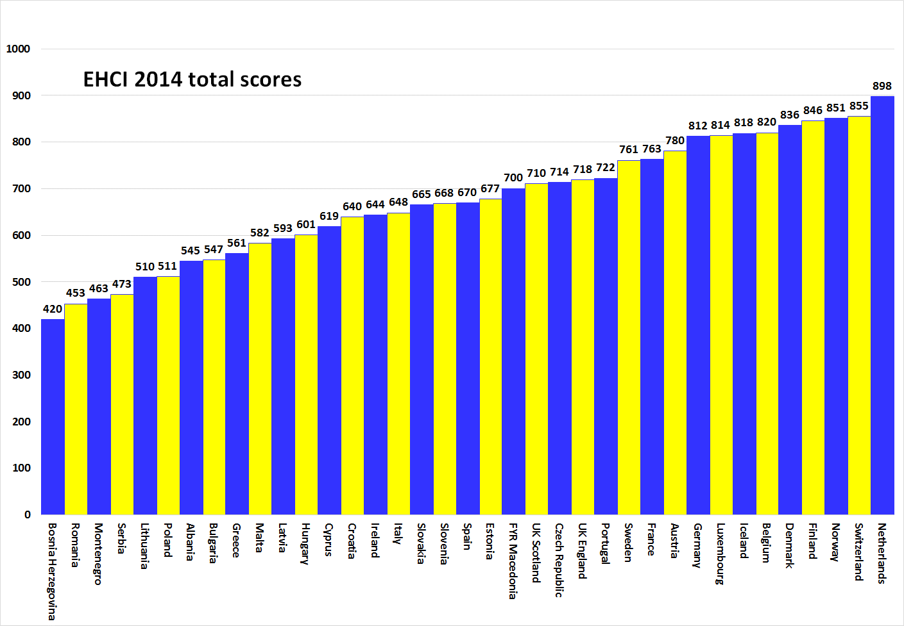

About HCP
The EHCI has become an “industry standard” of modern healthcare monitoring since the start in 2005. The Index is compiled from a combination of public statistics, patient polls and independent research conducted by Health Consumer Powerhouse Ltd, a Sweden-based private company, measuring the performance of healthcare in Europe and Canada to support patient and consumer empowerment. As the European Commission now will systematically engage in the assessment of member state health systems, EHCI sets an example.
The EHCI 2014 has been supported by unrestricted grants from Medicover S.A., Belgium, and New Direction Foundation, Belgium.
The EHCI material is published on the HCP website: www.healthpowerhouse.com . It is freely available and anybody is welcome to quote it, referring to the source.
For questions and information:
Arne Bjornberg: +46 70 584 84 51; arne.bjornberg@healthpowerhouse.com
Johan Hjertqvist: +46 70 752 18 99; johan.hjertqvist@healthpowerhouse.com

“We know the Euro Health Consumer Index (EHCI) is today the leading public measurement of how national healthcare systems perform ...We have recently learned that the European Commission after assessing various benchmarks has found the EHCI to be the most accurate and reliable comparison".
Dr. Vytenis Andriukaitis, Lithuania's Minister of Health, 2013 (since November 2014 the EU Commissioner of Health and Consumer Protection)
© HPC Ltd. 2015

