EHCI 2017
Media release Jan 29, 2018

What the annual EU healthcare review uncovers:
Why can small, poor countries eliminate waiting times in healthcare?
(Languedoc, January 29, 2018) European healthcare is steadily improving: infant mortality and survival rates of heart disease, stroke and cancer are all moving in the right direction. Patient choice and involvement are developing. But still too many countries stick to inefficient ways to fund and deliver care services. Learning from not only established success such as the Netherlands and Switzerland but also small countries doing the right thing can be a general improvement strategy: Finland, Slovakia, Montenegro and Macedonia. These are some main conclusions from the 2017 Euro Health Consumer Index (EHCI), published today by the Health Consumer Powerhouse (HCP) Ltd.
The EHCI, started in 2005, is the leading annual comparison for assessing the performance of national healthcare systems in 35 countries. The EHCI analyses national healthcare on 46 indicators grouped in areas such as Patient Rights and Information, Access to Care, Treatment Outcomes, Range and Reach of Services, Prevention and use of Pharmaceuticals. The 2017 Index ranks the countries (minimum score is 333, the maximum 1000) as follows:
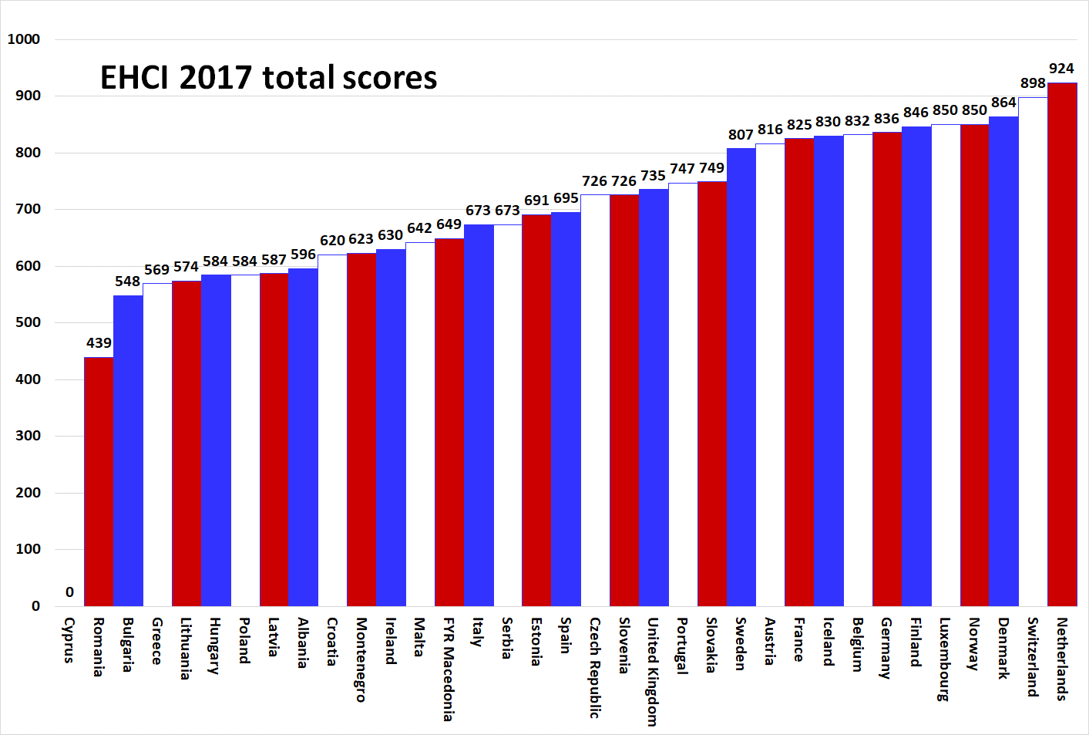
(Cyprus has been excluded from the ranking as it does not really have a public healthcare system in the general European sense; in Cyprus only 41% of healthcare costs are paid by public funds and 44% out-of-pocket. If the Index would count services obtained by people paying privately, practically all countries would get full scores.)

Tighter criteria
To keep the Index challenging and to reflect the rapid improvement of treatment results, this year HCP has decided to tighten some score criteria and introduce more stringent data such as 30-day case fatality for heart infarct and stroke. For infant mortality, the previous cut-offs between Green/Yellow/Red score of 4/6 deaths per 1000 live have been tightened to 3/5 deaths.
These adjustments seem to reward more affluent countries, with the NL still leading on 924 points. Switzerland is also holding out well on 898 points. Denmark is back among the medallists with 864 points. The most obvious change from 2016 is the 58-point gap now visible (in the graph above!) between the 12 countries of the “800 Club”, and those behind. Rewarding real excellence in treatment results seems to favour more affluent countries in the ranking.
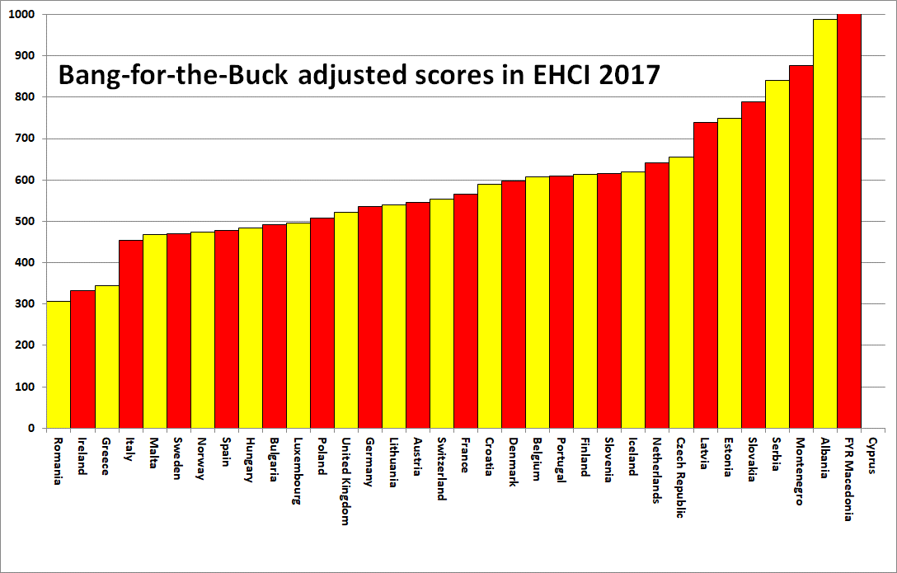
The value for money perspective shows that the overall winner, The Netherlands, can combine top performance with good value for money, together with Iceland and Finland. The NL is characterized by a multitude of health insurance providers (“Bismarck system”) acting in competition and being separate from caregivers/hospitals, unlike tax-funded NHS (“Beveridge”) healthcare systems. This means that Dutch operative decisions to an unusually high degree are taken by medical professionals counselled by patient organisations. Financing agencies, politicians and bureaucrats seem farther removed from operative healthcare decisions in the NL than in almost any other European country.
Waiting costs suffering – and money
Healthcare is basically a process industry. As any professional manager from such an industry would know, smooth procedures with a minimum of pause or interruption is key to keeping costs low! This is why process fragmentation with long waiting lists cause higher costs, not cost saving; the latter is a myth still heralded in most NHS system countries with abysmal waiting times such as Ireland, UK, Norway and Sweden.
In the EHCI 2017 there are some surprising newcomers among countries having no or minimal waiting lists in healthcare. Tiny Montenegro has achieved a similar improvement to what Macedonia did in 2013 by introducing a national real-time e-referral system. Slovakia shares the absolute Accessibility top with Switzerland. For a number of years Finland has been moving upwards in the EHCI and now combines low costs with top-class treatment results.
Inspiration
Looking into what such smaller healthcare systems can deliver (and the speed of change) would be good inspiration to many European governments. Since long EHCI has shown that Estonia and the Czech Republic belong to this group of small, value for money systems worth learning from.
The complete EHCI 2017 material – the full report, Index matrix, scoring sheets for each indicator as well as the media release are available on the HCP website https://healthpowerhouse.com/publications/euro-health-consumer-index-2017/

Further information: Professor Arne Bjornberg, HCP Chairman: arne.bjornberg@healthpowerhouse.com or +33-6-2330 1245
Johan Hjertqvist, HCP President: johan.hjertqvist@healthpowerhouse.com
or +46-70-752 1899.

