EHI 2016 media release

New EU heart study:
Irish heart care works but life style factors present a problem
Major inequalities in the use of basic heart medicines between countries
Heart care in Ireland ranks 12th among 30 measured countries, says the Euro Heart Index 2016 (EHI), published today in Brussels. The Index compares heart care in 30 European countries, with France the champion, closely followed by Norway and Sweden. Heart care improves in almost every country but the gaps across Europe threaten equity. Equal access to basic heart medication would save tens of thousands of lives.
"In heart care, Ireland shares a problematic pattern with many European countries”, says Dr. Beatriz Cebolla, the EHI Director. “The unhealthy lifestyle in the general population; with a rather high alcohol and sugar consumption and a small intake of vegetable and fruits and with a high percentage of population having high blood pressure. The number of people being obese is quite alarming, not only among the adult population but also among children. The system works efficiently and coordinated, offering good services but with some problems because of the notorious waiting list problems”, Dr. Cebolla adds.
Professor Arne Björnberg, the HCP chairman, explains the larger picture: “In heart care, there is a significant gap between European guidelines on how to treat patients, and how cardiac care is performed. The deployment of basic, cheap heart medicines seem haphazard, hardly reflecting the needs of the Europeans. More systematic use of therapies such as statins and clopidogrel would save thousands of lives!”
“Evidently, there is a connection between high spending and good outcomes. Affluent countries can afford admitting patients into hospital care on weaker indications, which can prevent that conditions grow worse”, adds Professor Bjornberg. "But a lot can be achieved also with small budgets, with the right priorities”.
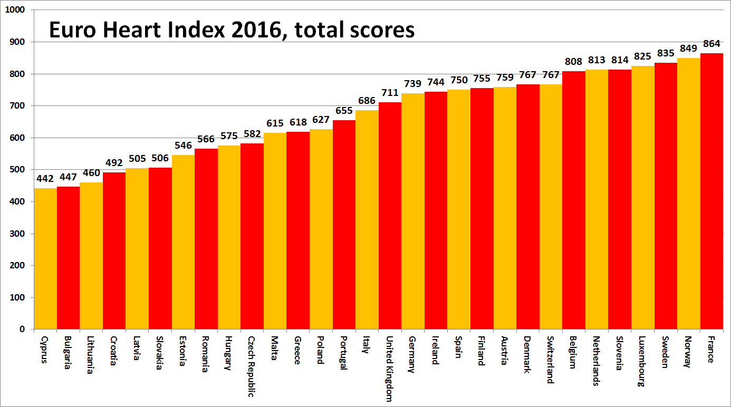
About the EHI
The Euro Heart Index provides a ranking of cardiovascular healthcare systems in 30 countries across four key areas: Prevention, Procedures, Access to care and Outcomes, measured on 31 indicators. The Index is constructed from public statistics and independent research. The producer of the EHI is the Health Consumer Powerhouse Ltd, which has been analysing performance of European national healthcare systems in around 50 index publications since 2004. All HCP indexes take a consumer-centric position. The production of the EHI 2016 was supported by an unrestricted grant from Amgen Europe GmbH.
Full EHI report with data and methodology explained, matrix and media releases are freely available on: www.healthpowerhouse.com/publications/euro-heart-index-2016/
For further information, please contact:
EHI project director: Dr. Beatriz Cebolla (beatriz.cebolla@healthpowerhouse.com),
+49 152 2371 9856
HCP Ltd chairman: Professor Arne Bjornberg (arne.bjornberg@healthpowerhouse.com),
+46 705 848451

(c) HCP Ltd. 2016

