European diabetes care has developed, saving 10 000 lives every year – but speedy improvement critical to meet the growth of diabetes, shows new EU comparison
Ireland should publish data on diabetes care procedures
(Vienna September 17, 2014) Diabetes care in Europe makes progress, shows a pan-European comparison of diabetes prevention and treatment presented today during the 50th Congress of the European Association for the Study of Diabetes (EASD) in Vienna. Since 2006 the combination of healthier lifestyle, better and broader patient education, better trained physicians and improved access to treatment and devices has reduced the number of deaths in Europe due to diabetes by 10 000 a year (plus an even larger reduction of deaths from diabetes-related heart disease).
But as more and more people will be diagnosed with diabetes over time, diabetes care must become much more efficient. This is the main message from the Euro Diabetes Index 2014, published today by the Sweden-based research organisation Health Consumer Powerhouse (HCP).
- Ireland ranked 20th among 30 European countries, explains Dr. Beatriz Cebolla, Index director. Often Ireland shadows UK in our health indices but here Ireland is far behind! Ireland has major public health problem, with an obese and sedentary population. Diabetes care suffers from a harmful paradox: there is good deployment of modern devices for patient disease management, such as test strips for insulin measurement, continuous blood-sugar monitoring and patient education. At the same time there are no reliable data whatsoever from monitoring of diabetes complications, such as blood-sugar, eye, foot and renal conditions.
- Why on earth do you deliver excellent services but refrain from keeping record of the outcomes, wonders Dr. Cebolla. Here Ireland is a sad exception in Northwestern Europe. This is a blueprint for inefficient diabetes care!
To improve diabetes care Dr. Cebolla points to the Index country recommendations for Ireland:
  - Start monitoring and publish data of diabetes care procedures re. blood-sugar levels as well as foot, eye and renal complications
  - Improve public health by addressing obesity, nutrition and physical exercise in schools
  - Upgrade the Irish diabetes registry to register and publish data on care procedures
  - Subsidise special footwear to improve access.
Diabetes still growing
The diabetes epidemic is taking its toll on European citizens with more than 32 million people diagnosed with the disease and many more undiagnosed. The cost of treatment in Europe in 2013 is estimated to €100-150 bn and set to rise even further, but the management of the disease in most countries is weak. Diabetes is still a major cause for kidney failure, blindness, foot and leg amputation and heart disease.

Despite the burden posed by the disease, most countries have no established best practice for treatment. Since 2008, when the very first Euro Diabetes Index was published, there has been very slow increase in the number of national diabetes registries. Still, most countries cannot present data on procedures and treatment outcomes.
- Searching for a European diabetes care best practice, you should look to top performers such as Sweden, the Netherlands and Denmark, recommends Dr. Arne Bjornberg, head of HCP Index research. But not even here prevention is really successful, which makes you worried about the future.
- These forerunners have a strong fundament for screening, registration and follow up for diabetes cases, explains Dr. Bjornberg. Fewer people fall between chairs and risk having complications. Procedures and outcomes are well documented, with reliable data. Nothing of this is rocket science but takes tedious ever-day efforts and co-operation to put in place. At the same time, it is hard to imagine how to address the diabetes growth without such best practice methodology!

Need for a diabetes best practice
The 2014 Euro Diabetes Index points to pillars for a potential pan-European best practice in diabetes prevention and care:
- Lack of regular exercise and inappropriate nutrition should be addressed, as they cause obesity – a major diabetes type 2 risk factor
- National diabetes registries – exist today in no more than seven of 30 compared countries
- Transparency must improve, making diabetes care data easier to access and compare
- Systematic screening among high-risk groups must become reality to detect undiagnosed cases – today such screening hardly exists in many countries
- Medication and other kinds of self-management devices must be sufficiently deployed
- Structured education for patients and relatives
- Regular check-ups for eye, foot and renal complications.
- The diabetes physicians (including GPs and nurses) need to be trained to understand and adopt and new technologies, to expand their proper use.

About the Index
The Index – a follow-up of the 2008 Euro Diabetes Index – covers the following areas, using 28 indictors: Prevention, Case finding, Range and reach of services, Access to treatment/care, Procedures and Outcomes.
Sweden comes out top with 936 of a maximum 1000 points, followed by the Netherlands (922), Denmark (863), United Kingdom (812) and Switzerland (799). Ireland (612) is 20th among 30 countries (EU 28 plus Norway and Switzerland).
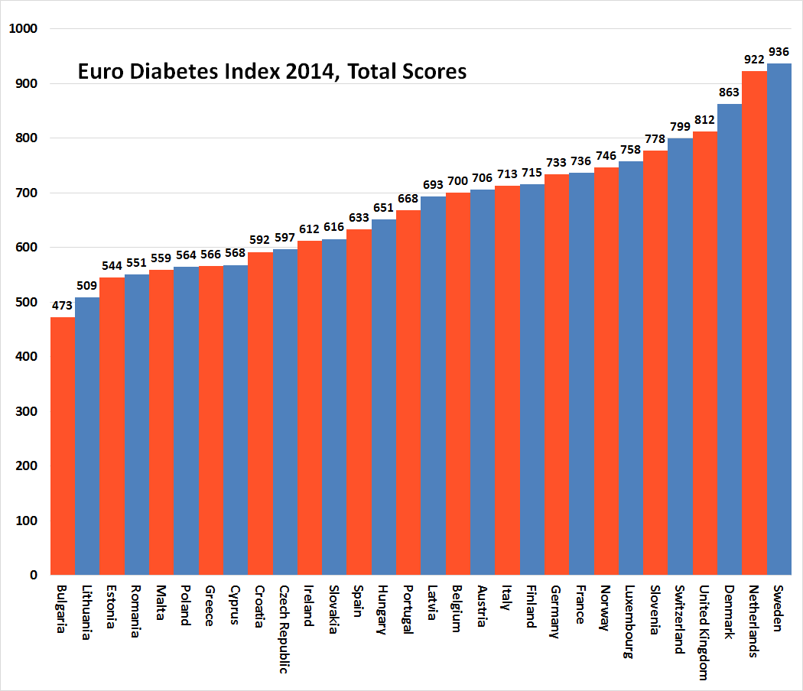

The full Index presentation, with the report, matrix and individual media releases for 30 countries, is available for free at www.healthpowerhouse.com. Please quote the source when using the material. The EDI will also be presented at an open webinar September 17, 09:00 – 11:00, http://bambuser.com/channel/healthpowerhouse
The 2014 Euro Diabetes Index has received an unrestricted grant from MSD.
For questions about the Index:
Arne Bjornberg, mobile phone: +46 705848451, arne.bjornberg@healthpowerhouse.com
Beatriz Cebolla, ⁺ 49 15223719856, beatriz.cebolla@healthpowerhouse.com
For more information about the 2014 Euro Diabetes Index, the launch webinar and the Health Consumer Powerhouse, please visit the Health Consumer Powerhouse website or contact us at info @healthpowerhouse.com. You can follow us on Facebook and Twitter: @HCPhealthindex

© HCP Ltd. 2014

