EHCI 2018 media release

Euro Health Consumer Index 2018:
The Netherlands dethroned by Switzerland in annual European health performance ranking
(Languedoc, February 25, 2019) For the first time in ten years, The Netherlands is not top of the EHCI. The “eternal runner-up” Switzerland has finally achieved the Gold position at 893 points (of a maximum of 1 000)! The NL comes in second with 883 points. Bronze medallists are Norway, at 857 points. Switzerland has for a long time had a reputation for having an excellent, although expensive, healthcare system, and it therefore comes as no surprise that rewarding clinical excellence results in a prominent position in the EHCI.
Three index indicators where almost all countries scored Green were removed in 2017 as non-discriminating. Two new indicators, reflecting performance on Access to psychiatric care for children and Suicide reduction, replaced two previous indicators with data quality problems. The new indicators mean increased attention to mental health aspects.
Professor Arne Bjornberg, the Health Consumer Powerhouse (HCP) Chairman, explains how the adjustment of indicators have affected the Index outcome: – Rather unexpectedly, The Netherlands had two high-weighted Green scores replaced by Red, thus losing 41 points in the total EHCI score. The NL is one of a half-dozen countries actually having had an increase of suicides this millennium.
European healthcare is steadily improving: infant mortality and survival rates of heart disease, stroke and cancer are all moving in the right direction. Patient choice and involvement are developing. Small countries with limited funding, such as the Baltic states, do well on child access to psychiatric care and reducing the suicide rate.
But still too many countries stick to inefficient ways to fund and deliver care services. Learning from not only established success such as the Netherlands and Switzerland but also small countries doing the right thing can be a general improvement strategy: Finland, Montenegro, North Macedonia and Serbia. Large countries often argue that running a minor healthcare system is much simpler. The Montenegrin success on Infant Mortality – today the lowest in Europe (the world?) – by having every risk pregnancy referred to the Clinical Centre of Podgorica could be repeated regionally in larger countries!
The EHCI, starting in 2005, is the leading annual comparison for assessing the performance of national healthcare systems in 35 countries. The EHCI analyses national healthcare on 46 indicators grouped in areas such as Patient Rights and Information, Accessibility, Treatment Outcomes, Range and Reach of Services, Prevention and use of Pharmaceuticals. The 2018 Index ranks the countries (minimum score is 333, the maximum 1000) as follows:

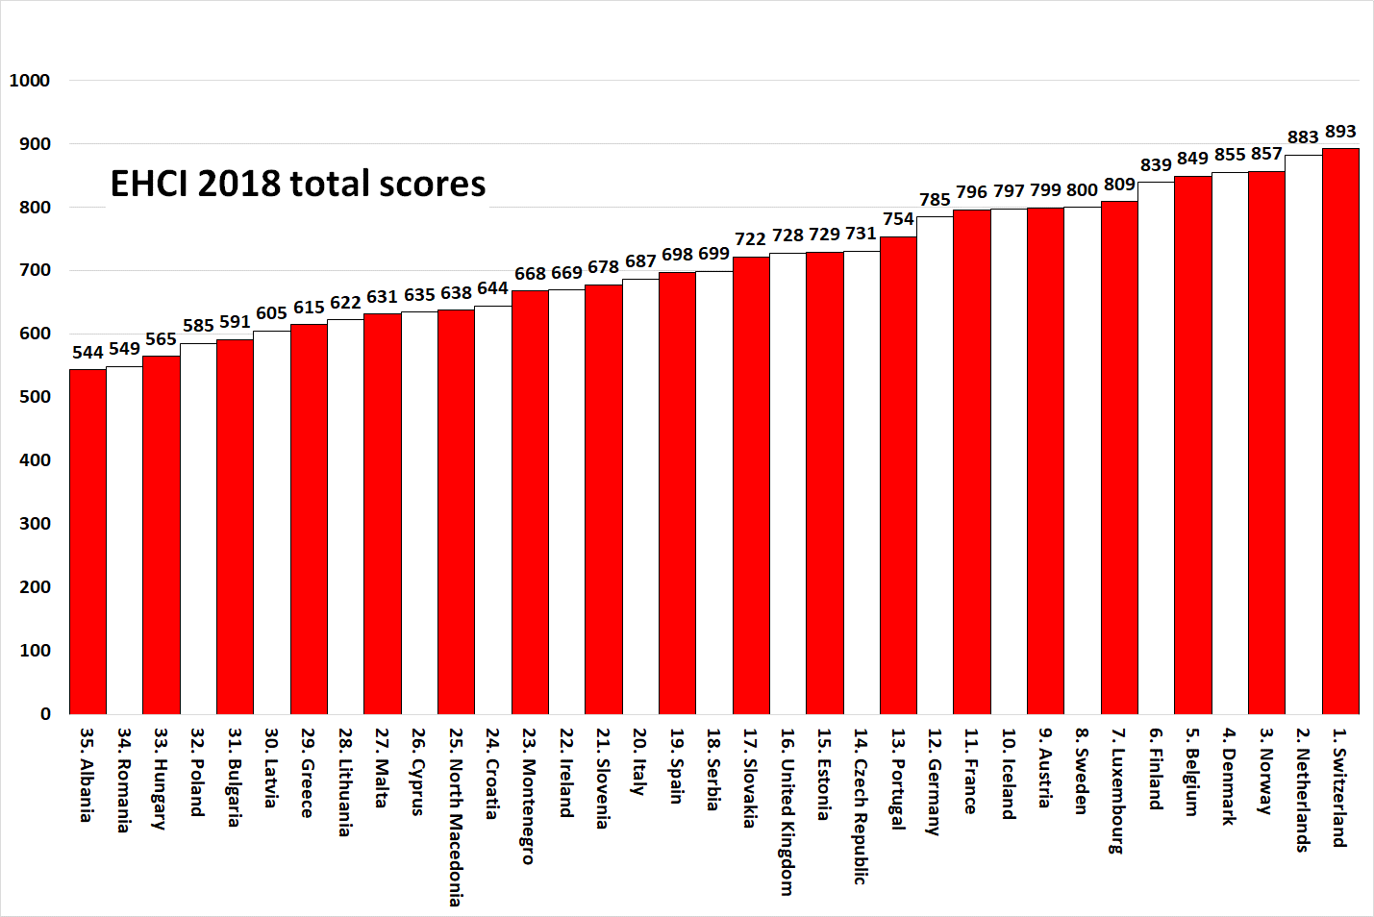

The scoring criteria have been tightened on some indicators in the EHCI 2018, in order to keep the Index challenging. Nevertheless, there are eight Western Europe countries making it into the “800 Club”, i.e. scoring more than 800 out of the theoretical maximum of 1000 (“All Green” on every indicator), with three more countries within four points of 800. The EHCI 2017 and 2018 reward real clinical excellence more than previous editions, creating a visible gap between the more affluent and the other countries: 31 points between #12 Germany and #13 Portugal, with another 23 points down to the Czech Republic.
The EHCI 2018 total ranking of healthcare systems, for the first time in a decade, does not have The Netherlands as the winner as it lost 41 points by the introduction of the two new Mental Healthcare-related indicators (NL now at 883 points). The top position in 2018 was taken by Switzerland, which lost only five points in the tightening of score criteria, scoring 893 points out of 1000.
Bronze medallist is Norway (857 points), which has been steadily climbing in the EHCI. Norway and Switzerland (with Finland) score highest on Outcomes. Were it not for the Norwegian loss of 87 points on Accessibility, Norway would be the supreme winner! Norway cannot blame the lack of funding for the waiting-time situation!
Denmark, in spite of not winning any sub-discipline, is fourth at 855 points.
Previous EHCI editions have shown that money does help to provide the best treatment as well as allowing hospital admissions on lighter indications, which might not be cost-effective but does provide better outcomes.
– On the other hand, there is no correlation between money and waiting times: it is cheaper to run a healthcare system without waiting lists than having waiting lists! Contrary to popular belief, not least among healthcare politicians, waiting lists do not save money – they cost money, Professor Bjornberg underscores. As shown by the Bang-for-the-Buck ranking below, some small countries with tiny budgets perform very well not least on Accessibility!
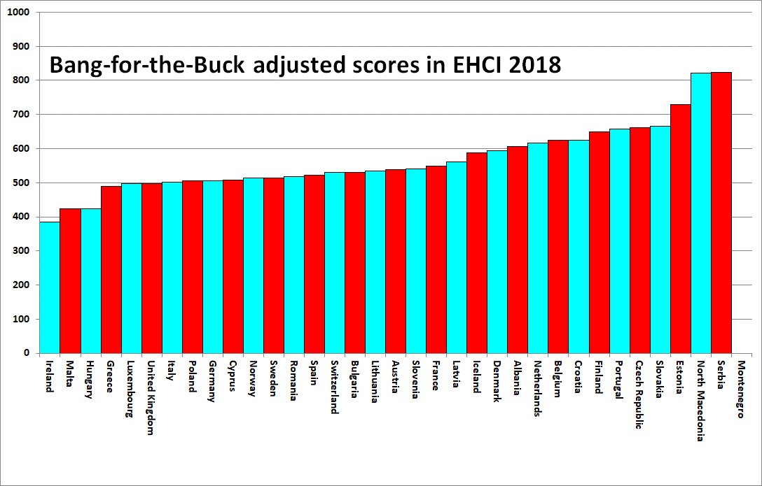
The tightening of score cut-offs has sacrificed the longitudinal analysis aspect, as a country can gain in the ranking even with a loss in score points; the EHCI 2006 – 2016 did show beyond reasonable doubt that European healthcare is continuously improving. And it is vital to remember that the EHCI is a strictly relative measure of national healthcare system performance!
The complete EHCI 2018 material – the full report, Index matrix, scoring sheets for each indicator as well as the media release are available on the HCP website https://healthpowerhouse.com/publications/ .
Further information: Professor Arne Bjornberg, HCP Chairman: arne.bjornberg@healthpowerhouse.com or +33-6-2330 1245. The week of February 25:
+381-62-813 3730.
Johan Hjertqvist, HCP Founder: johan.hjertqvist@healthpowerhouse.com
or +46-70-752 1899.

