EHI 2016 international media release

New EU heart study:
France has the best heart care in Europe, followed by Norway and Sweden
Major inequalities in the use of basic heart medicines between countries
Heart care in France ranks 1st among 30 measured countries, says the Euro Heart Index 2016 (EHI), published today in Brussels. The Index compares heart care in 30 European countries, with France the champion, closely followed by Norway and Sweden. Heart care improves in almost every country but the gaps across Europe threaten equity. Better prevention and equal access to basic heart medication would save tens of thousands of lives.
"In heart care, France leads Europe”, says Dr. Beatriz Cebolla, the EHI manager. “France’s position depends on the combination of healthy life style factors and a well-coordinated system which provides easily accessed heart care."
France is recognized as having the lowest heart disease mortality in Europe and has today been joined by eleven other countries where heart disease no longer is the biggest killer disease. Among these are Norway, 2nd in the EHI, as well as Luxembourg (4th) and Slovenia (5th).
Professor Arne Björnberg, the HCP Chairman, explains the larger picture: “In heart care, there is a significant gap between European guidelines on how to treat patients, and how cardiac care is performed. The deployment of basic, cheap heart medicines seem haphazard, hardly reflecting the needs of the Europeans. More systematic use of therapies such as statins and clopidogrel would save thousands of lives!"
"Evidently, there is a connection between high spending and good outcomes. Affluent countries can afford admitting patients into hospital care on weaker indications, which can prevent that conditions grow worse", adds Professor Björnberg. "But a lot can be achieved also with small budgets, with the right priorities".
The EHI report concludes: "There is a “prevention deficit” in most European healthcare systems", pointing to a number of measures to be taken to activate prevention.
Except for pan-European action on smoking, not very much has happened to improve healthy lifestyles. Prevention remains the big unexploited potential for better heart conditions and survival.

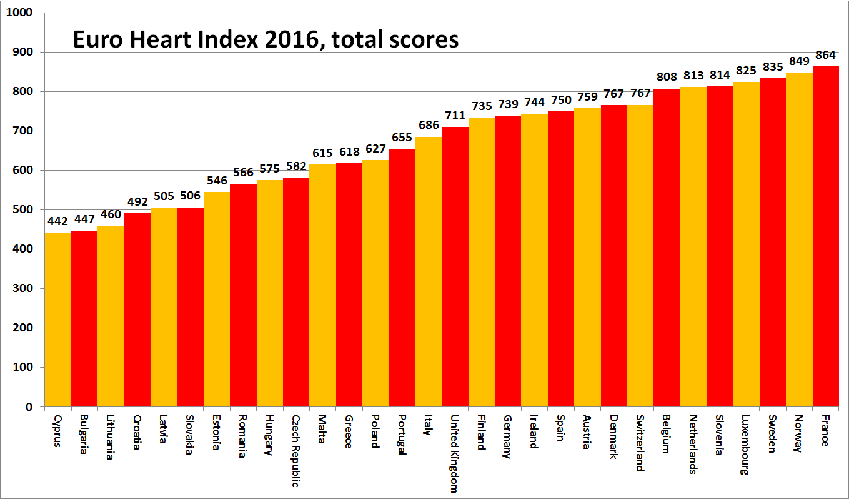

About the EHI
The Euro Heart Index provides a ranking of cardiovascular healthcare systems in 30 countries across four key areas: Prevention, Procedures, Access to care and Outcomes, measured on 31 indicators. The maximum points achievable are 1 000. The Index is constructed from public statistics and independent research. The producer of the EHI is the Health Consumer Powerhouse Ltd, which has been analysing performance of European national healthcare systems in around 50 index publications since 2004. All HCP indexes take a consumer-centric position. The production of the EHI 2016 was supported by an unrestricted grant from Amgen Europe GmbH.
Full EHI report with data and methodology explained, matrix and media releases are freely available on: www.healthpowerhouse.com/publications/euro-heart-index-2016/
For further information, please contact:
EHI Project Director: Dr. Beatriz Cebolla (beatriz.cebolla@healthpowerhouse.com),
+49 152 2371 9856
HCP Ltd. Chairman: Professor Arne Bjornberg (arne.bjornberg@healthpowerhouse.com),
+46 705 848451
(c) HCP Ltd. 2016

